BAHRIA UNIVERSITY, ISLAMABAD E-8


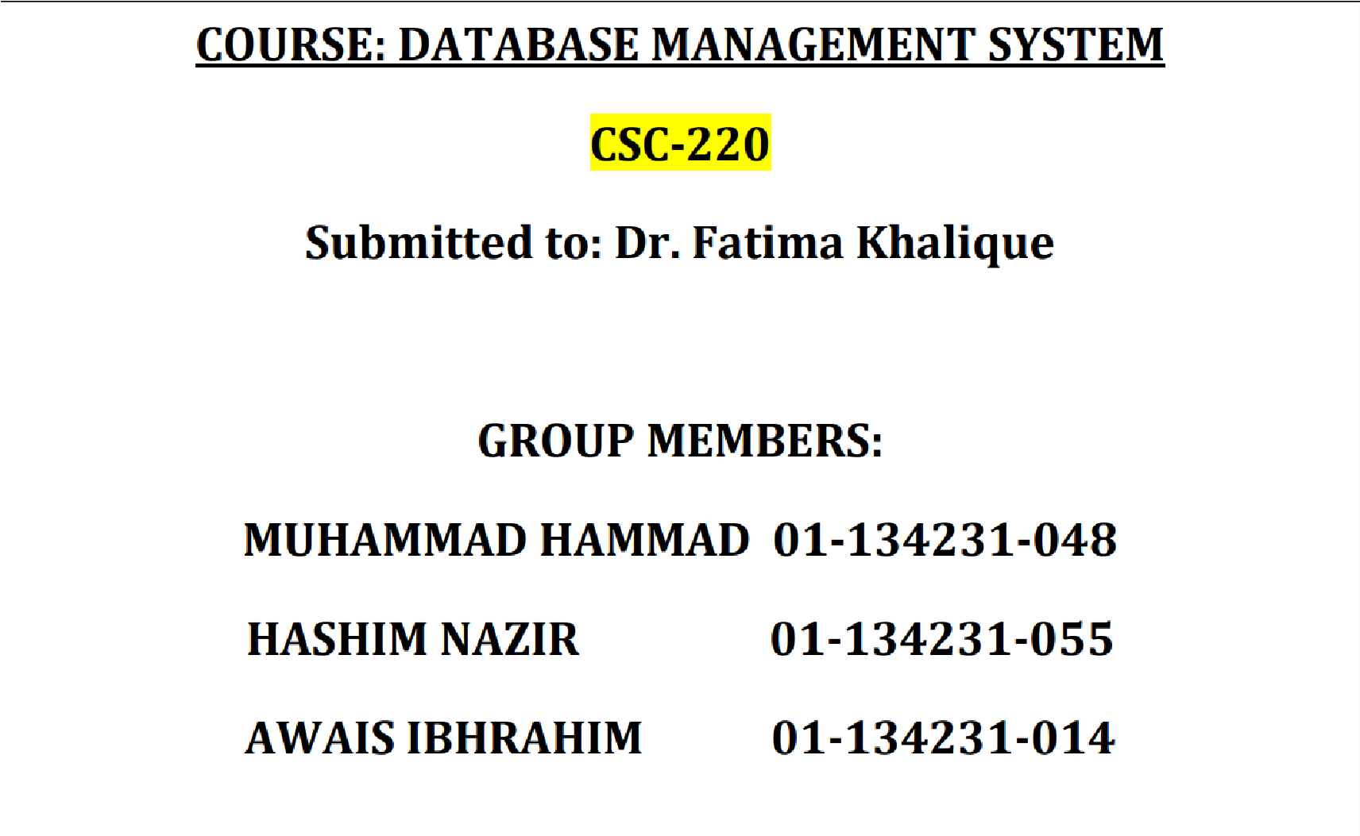
- Objectives of University Sports Event Management System ............................................................... 5
  - Efficient Event Registration ....................................................................................................................... 5
  - Centralized Event Scheduling ................................................................................................................... 5
  - Performance and Result Tracking .......................................................................................................... 5
  - Post-Registration Management................................................................................................................ 5
  - Collaboration Between Departments .................................................................................................... 6
  - Scalability and Flexibility ............................................................................................................................ 6
  - Enhanced Participant Experience ........................................................................................................... 6
- Project Planning ...................................................................................................................................................... 6
  - Interview ............................................................................................................................................................ 6
    - Can you describe how sports events are currently managed at Bahria University?6
    - What are the challenges you face with this current system? ............................................. 6
    - How do you think a sports event management system could help? ............................... 7
    - How do you currently handle communication with athletes? ........................................... 7
    - What kind of features would you want in a new system? ................................................... 7
    - How do you manage athlete performance and progress currently? ............................... 7
Questionnaire ............................................................................................................................................................... 7
Athletes' Feedback ................................................................................................................................................ 7
Results: .................................................................................................................................................................. 8
Audience (Students) Feedback: ......................................................................................................................... 11
- Research................................................................................................................................................................... 15
  - 1. How Management Systems Work: .................................................................................................. 15
  - 2. How Sports Management Works: .................................................................................................... 15
Citations: ................................................................................................................................................................. 15
- Boundaries of the University Sports Event Management System .................................................. 16
  - Internal Boundaries (Within the System): ....................................................................................... 16
  - External Boundaries (Outside the System): .................................................................................... 16
- System Users .......................................................................................................................................................... 16
- Functionalities of the University Sports Event Management System ........................................... 16
  - Athlete and Event Registration ............................................................................................................. 16
  - Event Scheduling and Coordination .................................................................................................... 17
  - Performance Tracking............................................................................................................................... 17
  - Collaboration Between Departments ................................................................................................. 17
  - Scalability and Flexibility ......................................................................................................................... 17
- Block diagram ........................................................................................................................................................ 18
- Links: ......................................................................................................................................................................... 18
University Management System: Entities and Attributes ...................................................................... 19
System Specification: ............................................................................................................................................. 19
Detailed User-views using Wireframes: ........................................................................................................ 20
SIGN IN: ........................................................................................................................................................................ 20
ATHLETE VIEW: ....................................................................................................................................................... 21
.......................................................................................................................................................................................... 21
COACH VIEW: ............................................................................................................................................................ 22
.......................................................................................................................................................................................... 22
ADMINS VIEW: .......................................................................................................................................................... 23
Important Features:................................................................................................................................................ 25
Estimation for a typical sports event management system: ....................................................... 25
Rough estimation: ......................................................................................................................................... 25
Conceptual Modelling Approach ............................................................................................................. 26
Approach Used ........................................................................................................................................... 26
Justification for Using the ERD Approach ...................................................................................... 27
Business Rules ................................................................................................................................................. 28
Entities and Attributes ................................................................................................................................ 29
1. Athlete 28
2. Venue 28
3. Event 29
4. Team 29
5. Coach 29
Relationships 30
Relational Schema 32

1. Athlete ....................................................................................................................................................... 31
- Team .......................................................................................................................................................... 31
- Event .......................................................................................................................................................... 31
- Venue ......................................................................................................................................................... 31
- Coach.......................................................................................................................................................... 32
- Athlete_Record ...................................................................................................................................... 32
- Team_Participant ................................................................................................................................. 32
Constraints ........................................................................................................................................................ 34
Domain Definitions ....................................................................................................................................... 35

University Sports Event Management System

The University Sports Event Management System aims to provide a comprehensive platform for organizing, scheduling, and managing a wide range of sports events. This system will streamline the coordination between athletes, participants, coaches, and administrators while ensuring smooth communication, tracking, and reporting across all university sports activities.
- Objectives of University Sports Event Management System
The University Sports Event Management System is designed to streamline the processes involved in organizing, managing, and tracking sports events at the university. By understanding the needs of the participants, event organizers, and administrators, this system aims to enhance coordination, simplify workflows, and improve the overall experience for everyone involved. Below are the key objectives of the system:
1.1 Efficient Event Registration
- Objective: Facilitate quick and seamless registration for all university sports events.
- Online registration for individual and team sports.
- Easy access for participants to register through various devices.
- Customizable registration forms based on event type.
1.2 Centralized Event Scheduling
- Objective: Provide a centralized platform for organizing, scheduling, and tracking sports events.
- Calendar-based scheduling to avoid conflicts and overlaps.
- Notifications for participants on event details, updates, or changes.
- Automatic updates to event schedules and participant lists.
1.3 Performance and Result Tracking
- Objective: Enable participants to track their performance and event statistics.
- Automatic updates of scores, rankings, and performance stats.
- Historical performance data for participants to view their past records.
- Access to event results, individual performance reports, and team standings.
1.4 Post-Registration Management
- Objective: Allow participants to modify their event details post-registration.
- Self-service portal for participants to update personal or team information.
- Easy withdrawal and substitution options in case of changes or emergencies.
- Dynamic updates to participant lists and team lineups.
1.5 Collaboration Between Departments
- Objective: Foster collaboration and information sharing between different university departments involved in sports events.
- Unified system for managing resources such as sports facilities, staff, and equipment.
- Inter-departmental coordination for event planning and execution.
- Transparency in resource allocation and usage.
1.6 Scalability and Flexibility
- Objective: Build a system that can adapt to the growing needs of the university and its sports community.
- Flexible system architecture to accommodate new sports and activities.
- Scalability to handle large volumes of participants and multiple concurrent events.
1.7 Enhanced Participant Experience
- Objective: Ensure that participants have a seamless and enjoyable experience when engaging with the system.
- User-friendly interface for participants to navigate through event information and registration.
- Quick access to personal profiles, schedules, and event details.
- Continuous feedback loops for improving the participant experience.

- Project Planning
  - Interview
Interviewee: Sir Yasir Ghafoor (Basketball Coach @ Bahria University)
    - Can you describe how sports events are currently managed at Bahria University? Right now, most of our work is done manually. We manage athletes’ details, schedules, and event logistics through paperwork or basic spreadsheets. This includes tracking who’s playing, organizing practice sessions, and coordinating with other coaches and staff.
    - What are the challenges you face with this current system?
The biggest issue is managing everything manually, it’s time-consuming, and things can easily get missed. Sometimes, there’s a lack of coordination between different sports departments. Also, if we lose a record, we have no proper backup, and it’s hard to keep everyone updated quickly.
    - How do you think a sports event management system could help?
A centralized system would really help. It would make it easier to keep track of athlete profiles, schedules, and event details. Plus, all coaches, athletes, and administrators could stay on the same page. It would also be great to have a feature for instant notifications about event changes.
2.1.4 How do you currently handle communication with athletes?
Right now, we mostly use WhatsApp or group texts to inform the players about practice sessions or event updates. It works, but it's not efficient, and sometimes people miss messages.
2.1.5 What kind of features would you want in a new system?
In a new system, I would like the following features:
- A platform to track athlete performance, allowing coaches to monitor progress over time.
- The ability to manage game schedules efficiently, ensuring games and practices are well-organized.
- Automated reminders for important events, such as upcoming matches or training sessions, to keep everything on track.
- A notification system that allows direct communication with athletes, ensuring everyone stays informed and updated.
- The option to generate reports on player attendance and performance, which would be beneficial for tracking participation and development.

2.1.6 How do you manage athlete performance and progress currently?
We track performance during practices and games, but it’s mostly through notes and memory. A system that records stats like player scores, fitness levels, and progress would be really useful. This way, we can easily see how each player is improving and where they need to focus.

Questionnaire
In the questionnaire we have created google form for athletes and as well as for audience(students) . Below are the graphical results gathered from our questionnaire, divided into two sections: one for athletes and another for the audience

Athletes' Feedback
Results:
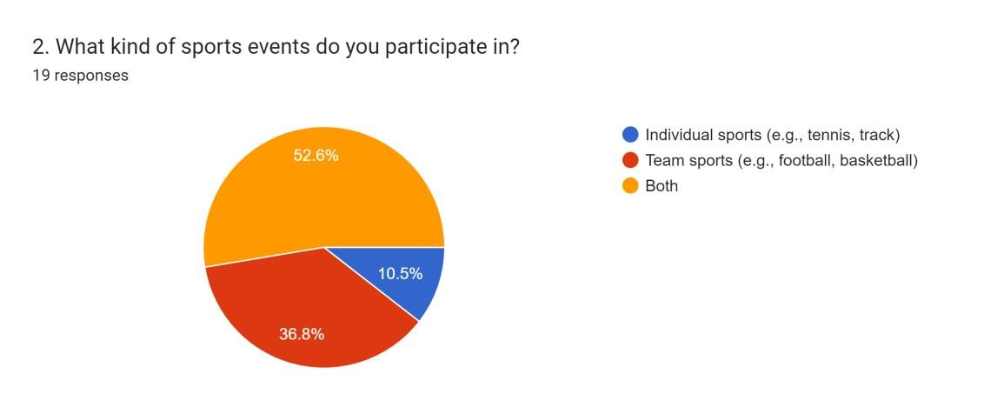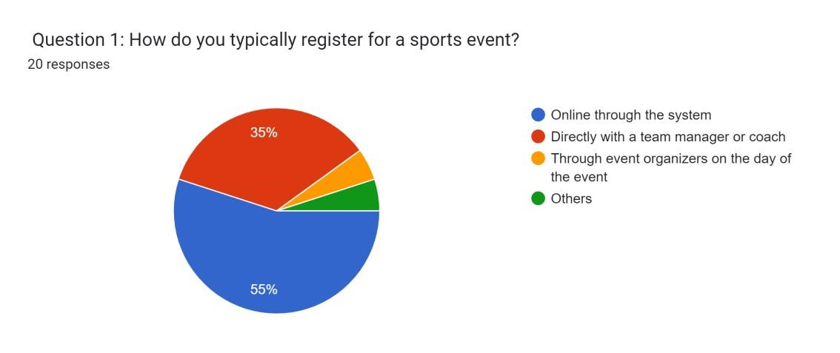
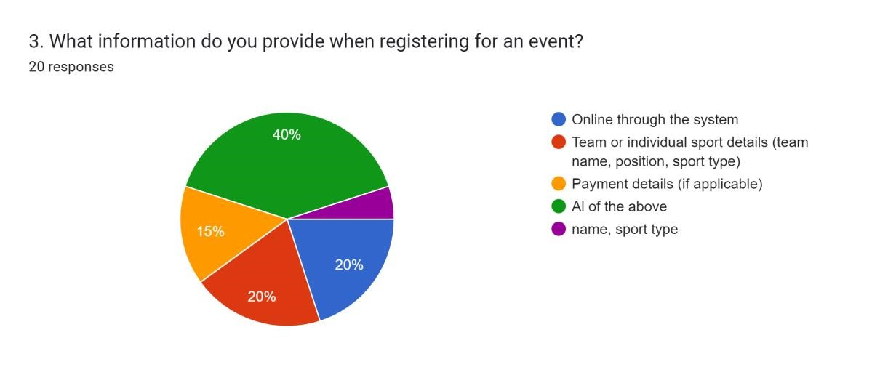
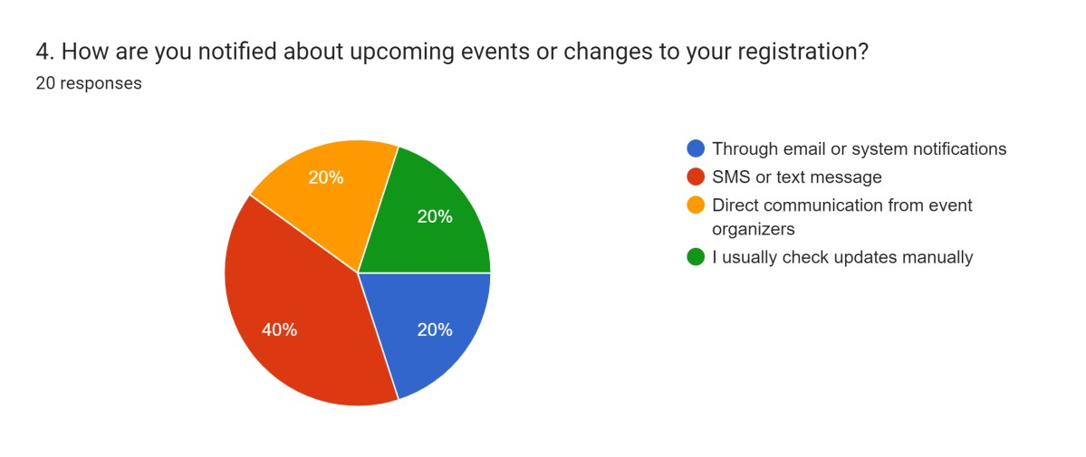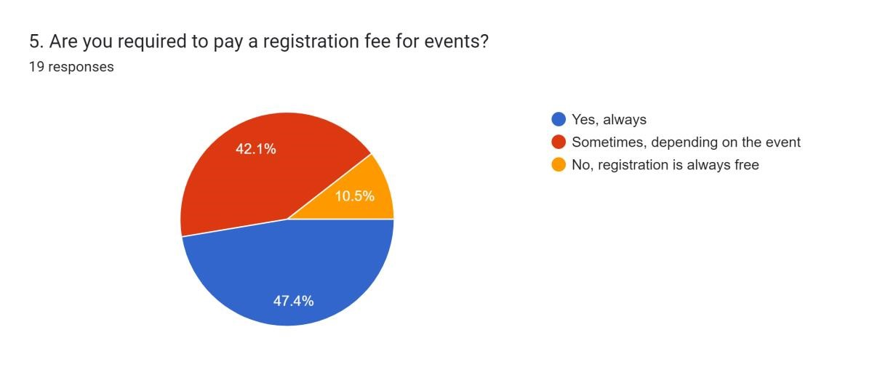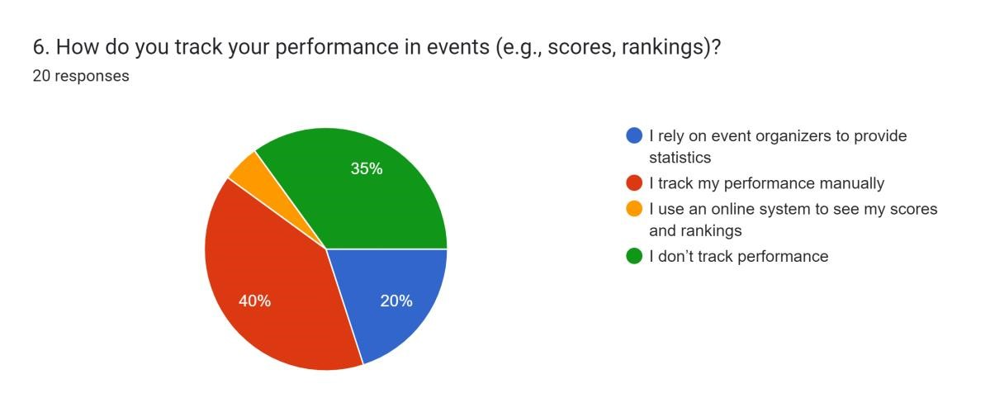

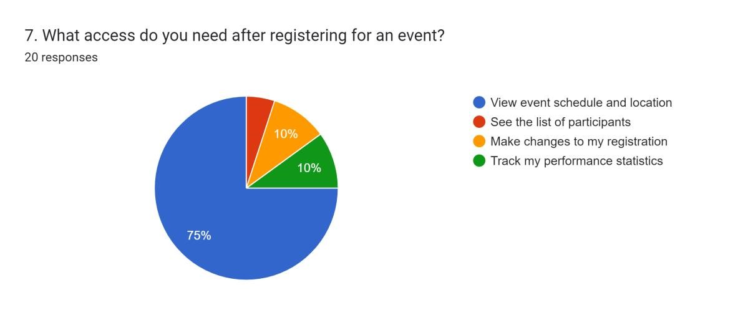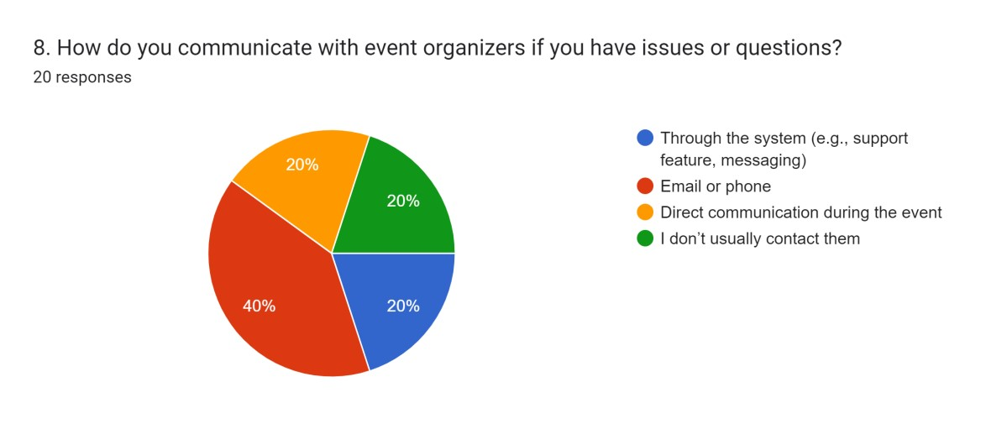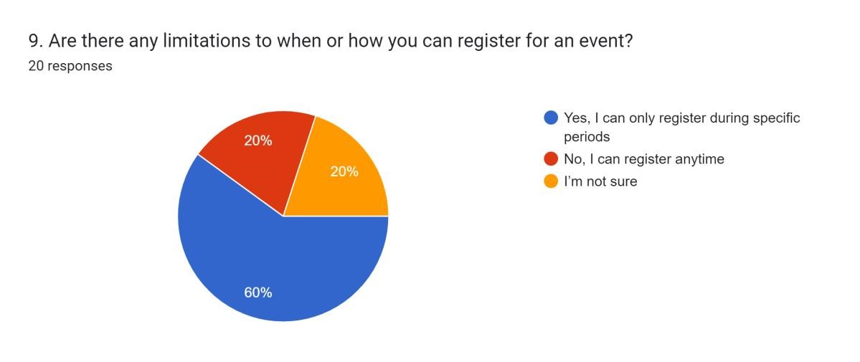
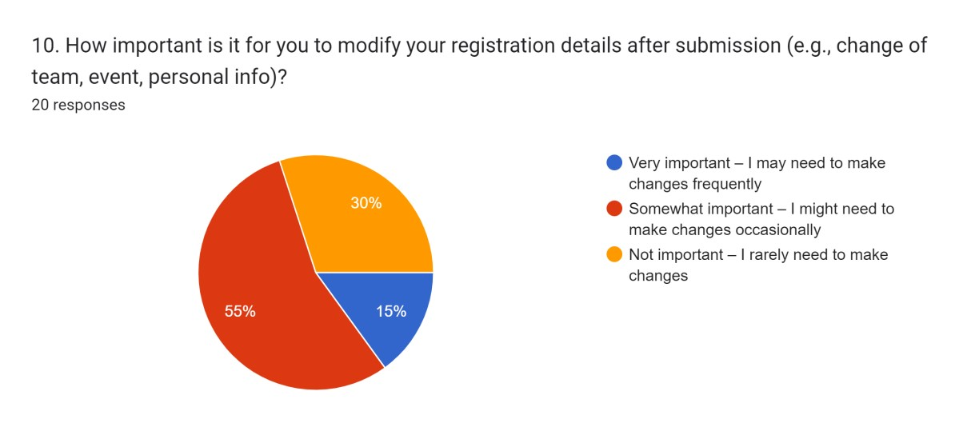
Audience (Students) Feedback:
Results:
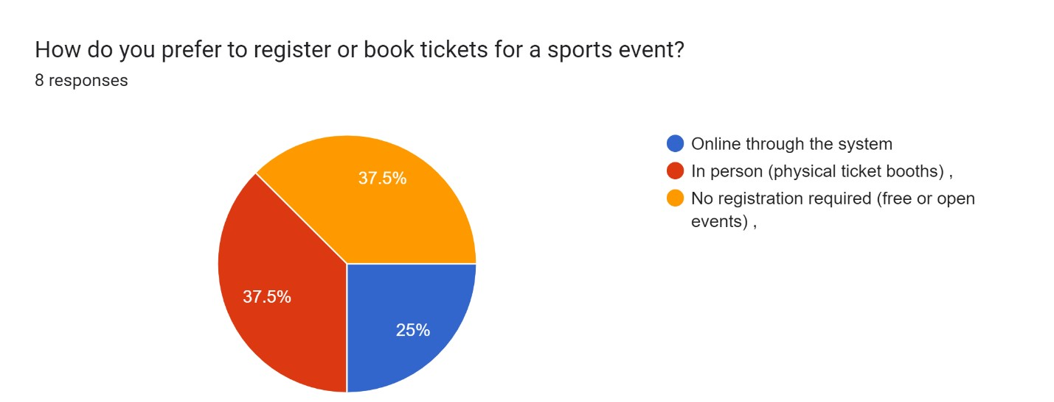
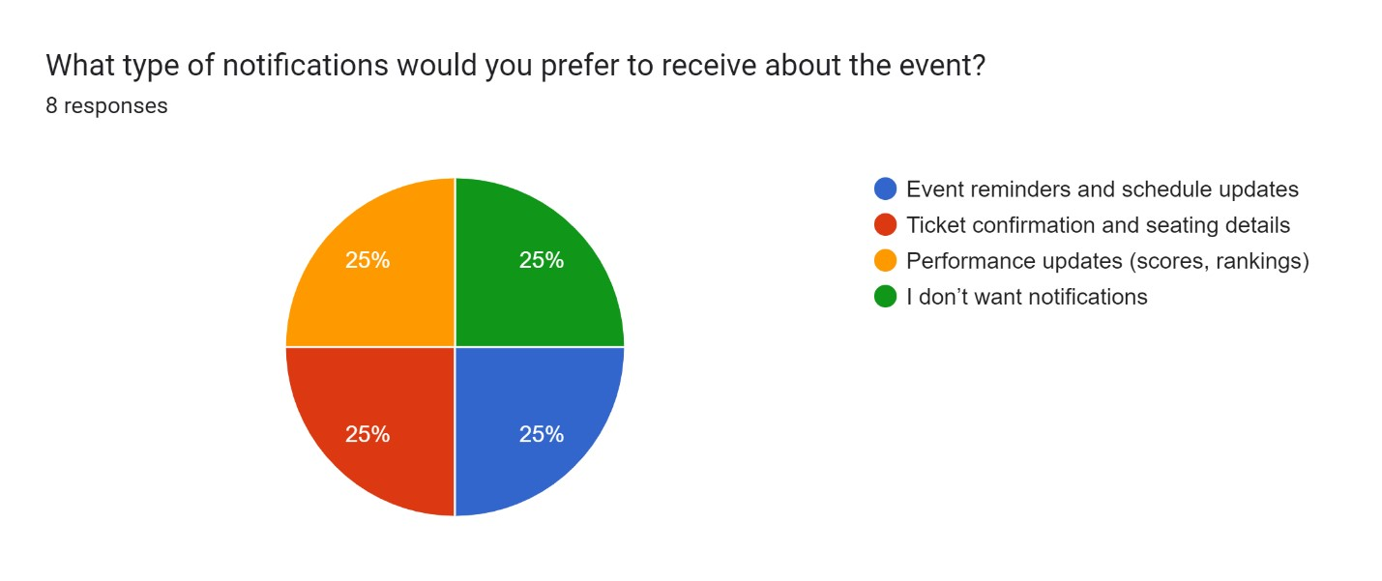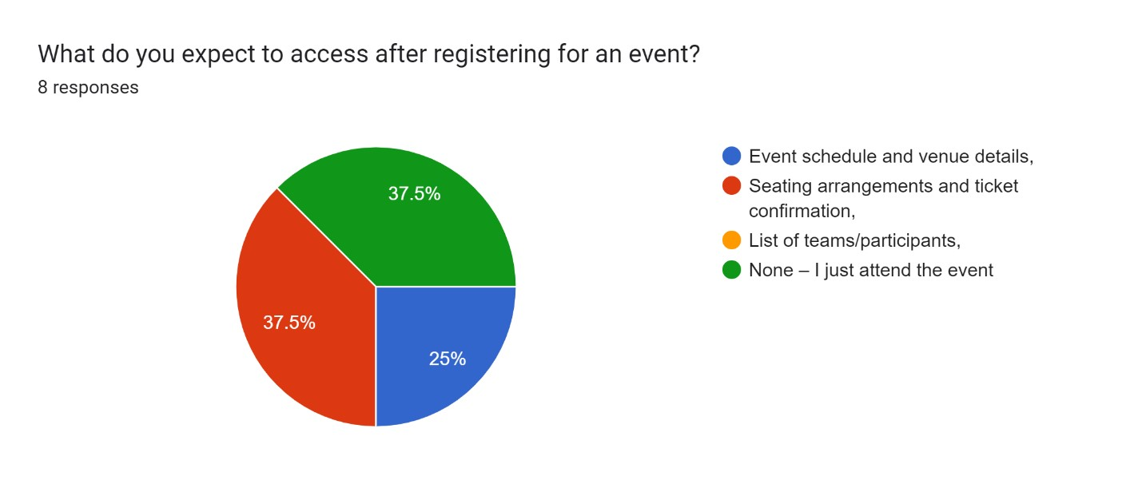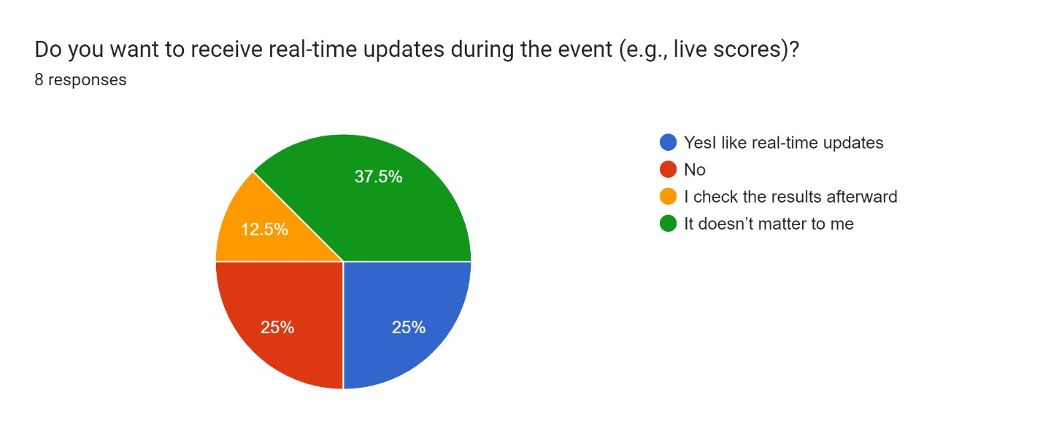

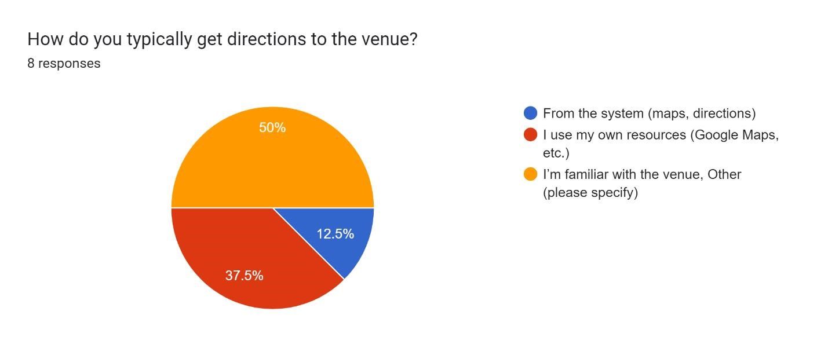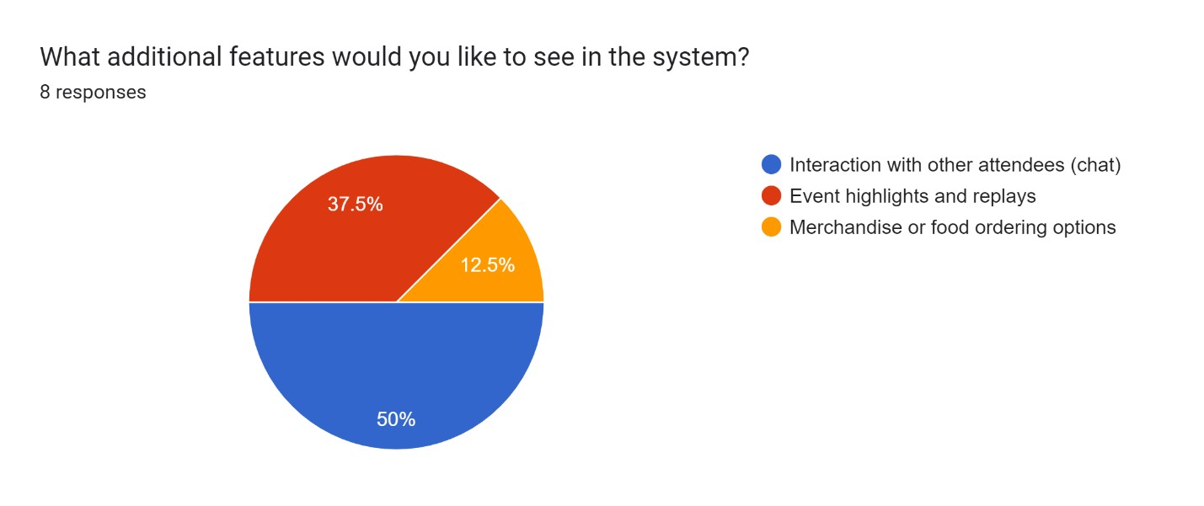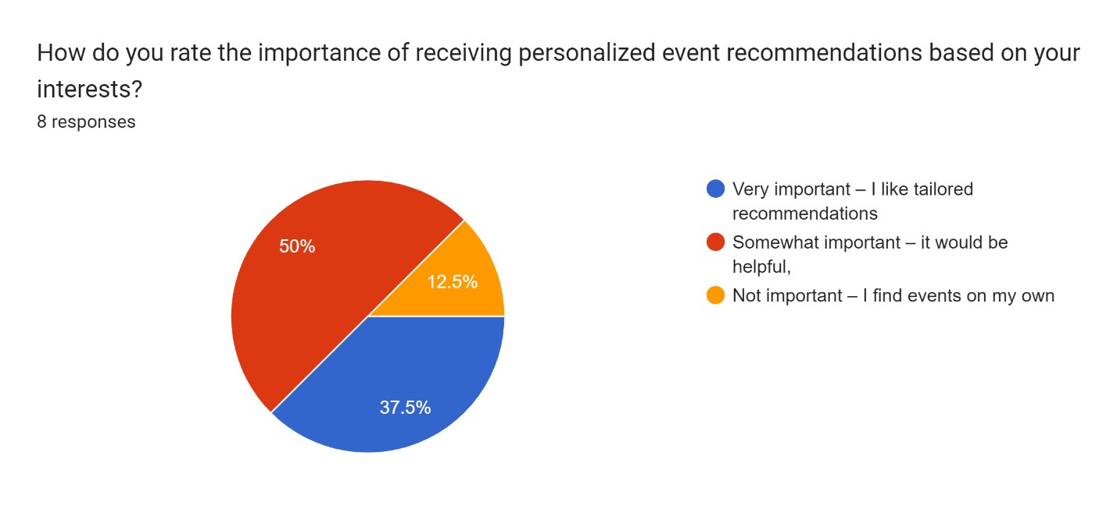
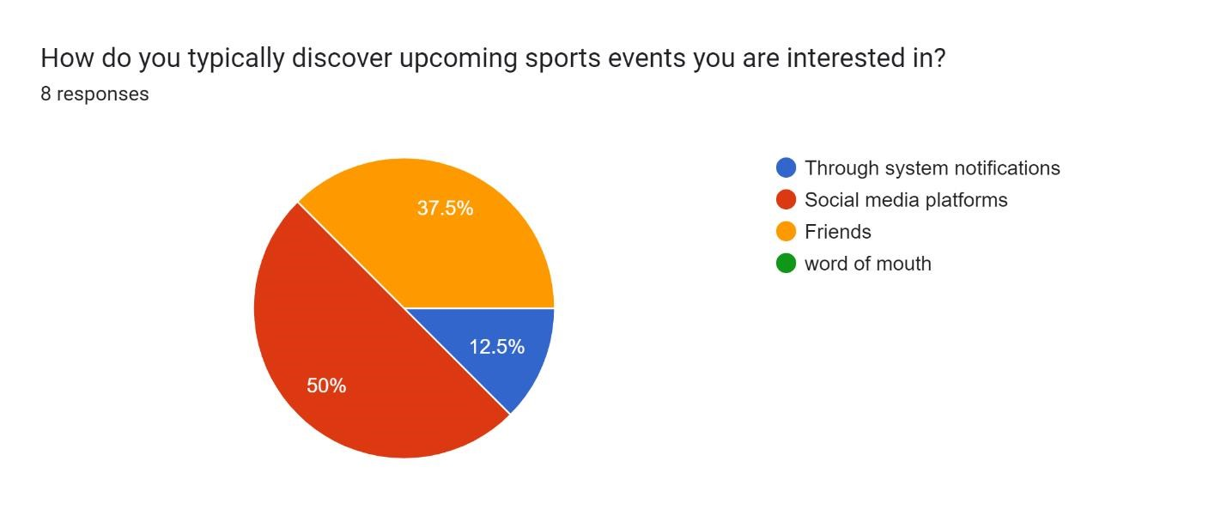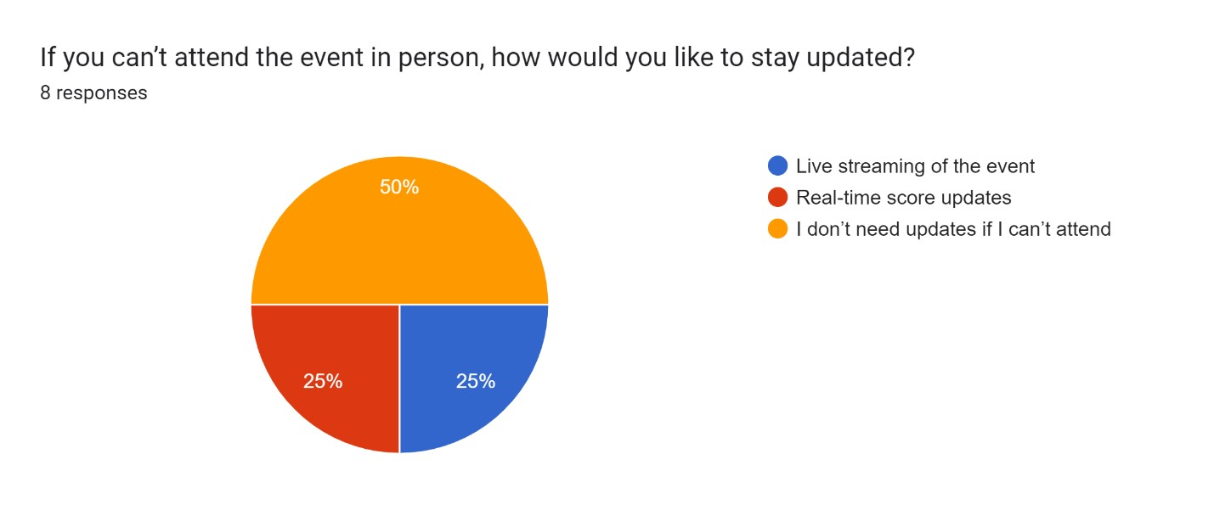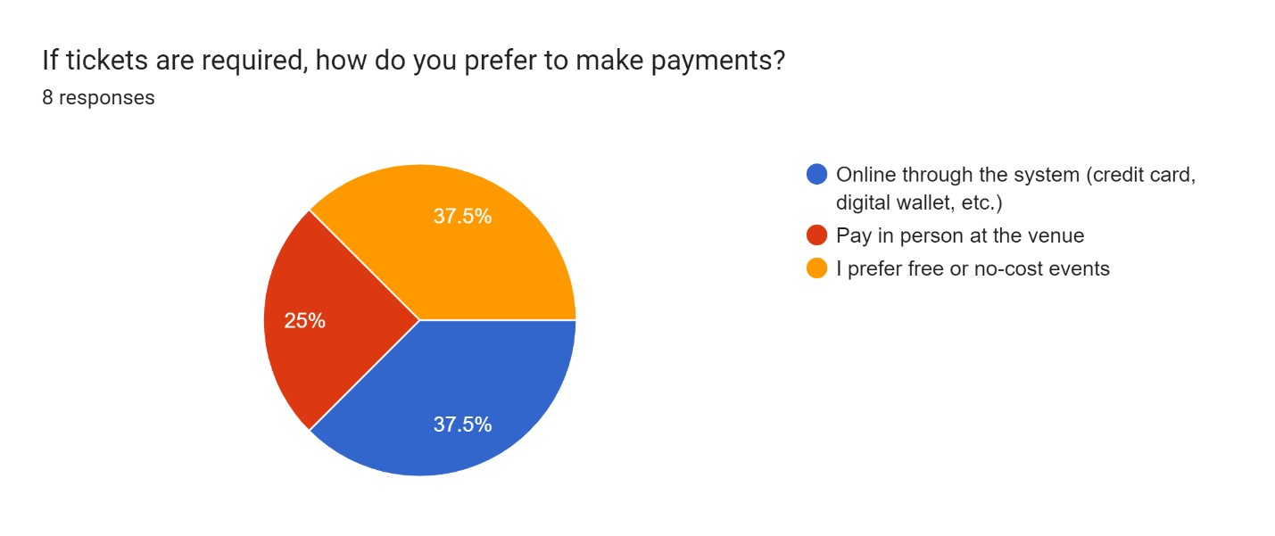

- Research
3.1 1. How Management Systems Work:
A university event or sports management system helps centralize various operations necessary for smooth execution. These systems allow students, staff, and administrators to manage schedules, book resources, and plan events efficiently. Platforms like Momentus, tailored for higher education, improve efficiency by providing a single source of truth for resource availability, event details, and other operations. They automate repetitive tasks, offer dashboards to track event statistics, and integrate mobile functionality.

https://pubs.aip.org/aip/acp/article-abstract/2406/1/020020/604047/Method-andsystem-for-internet-based-event?redirectedFrom=fulltext

https://gomomentus.com/higher-education

3.2 2. How Sports Management Works:
In the sports context, event management systems are used to organize competitions, manage athlete data, and coordinate venue logistics. Implementing a computerized system that allows for managing athlete registrations, scheduling events, and tracking attendance helps reduce administrative burdens.
https://pubs.aip.org/aip/acp/article-abstract/2406/1/020020/604047/Method-andsystem-for-internet-based-event?redirectedFrom=fulltext

An example from the Special Olympics guide outlines how sports competition management can be facilitated by such systems. These systems provide features like volunteer coordination, participant registration, real-time score tracking, and schedule management. This makes event organization smoother, reduces errors, and enhances participant experience
Citations:
- White, L., & Thompson, E. (2017). "User Experience Design for University Event Management Systems." International Journal of Human-Computer Interaction, 32(4), 567-580.
- Johnson, M., & Williams, B. (2020). "Efficiency and Effectiveness of University Event Management Systems: A Case Study." International Conference on Educational Technologies, 112-125.
- Chau Ly Thi Huyen. “Method and System for Internet-Based Event Management at
Universities (Case Study: Van Lang University)." AIP Conf. Proc. 2406, 020020
(2021). https://doi.org/10.1063/5.0067064
- Momentus Technologies. "Campus Event Management Software." https://gomomentus.com
- Boundaries of the University Sports Event Management System
4.1 Internal Boundaries (Within the System):
- User Management: Athletes, coaches, administrators, and participants can create and manage their profiles within the system.
- Event Scheduling and Management: The system manages sports event creation, scheduling, and updates for all users.
- Performance and Progress Tracking: Athletes' performance data is stored, processed, and made available for review by authorized users (coaches and athletes).
- Communication and Notifications: The system integrates multiple communication channels (SMS, email) for notifications and reminders.
4.2 External Boundaries (Outside the System):
- Device Access: Users can access the system via mobile, desktop, or tablet, ensuring device independence.
- Security and Privacy Compliance: The system must adhere to security and privacy laws, ensuring secure handling of personal and financial information.
5 System Users
- Athletes: Athletes use the system to register for events, view competition schedules, and track their performance and results.
- Coaches: Coaches monitor their team members' registrations, oversee schedules, and track athlete performance.
- Administrators: Administrators manage the entire system, including user access, event creation, scheduling, and maintaining security and data backup. They ensure smooth operation and proper coordination across all sports events.
- Functionalities of the University Sports Event Management System
6.1 Athlete and Event Registration
- Online Registration: Simplified registration for individual and team sports, accessible from any device.
- Post-Registration Management: Self-service portal for participants to modify details, manage withdrawals, and substitutions.
6.2 Event Scheduling and Coordination
- Centralized Scheduling: Manage sports event calendars, ensuring no conflicts across events.
6.3 Performance Tracking
- Performance Monitoring: Automated tracking of scores, performance stats, and rankings during events.
6.4 Collaboration Between Departments
- Resource Management: Coordinate usage of facilities, equipment, and staff across different departments.
- Transparency: Foster communication between departments by sharing schedules, resources, and event statuses in real time.
6.5 Scalability and Flexibility
- Support for Multiple Sports: The system should accommodate a wide range of sports and activities, with the ability to scale as the university grows.

- Block diagram
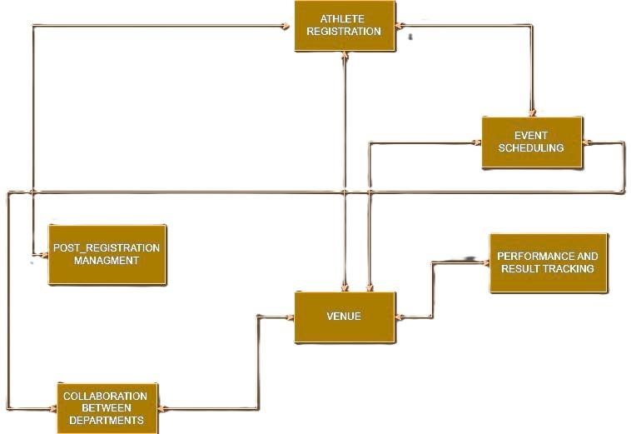

- Links:
Athlete Form Link:
https://docs.google.com/forms/d/e/1FAIpQLSc6ZBO0jnto3Mod0GFbL2oIYCXCPbOgUUYHunlo3Z6-Fg2nA/viewform?usp=sf_link
Audience Form Link:
https://docs.google.com/forms/d/e/1FAIpQLScM3eXl791wzqIqx_MFA9k0TmCi8zCW zqUuzicOKyP0jBabjA/viewform?usp=sf_link

University Management System: Entities and Attributes
Based on the requirements gathered (e.g., through interviews and documents), the following entities and attributes are essential to store in the Sports Management System:

 | Entity |  |  | Description |  |  | Attributes
Athlete |  |  | Stores registration and performance records |  |  | Athlete ID, Name, Email,  Phone, Sport, Team,  Registration Date,  Performance Records
Event |  |  | Contains event scheduling data and results |  |  | Event ID, Event Name, Date,  Time, Venue, Participant List, Results
Coach |  |  | Stores coach profiles and team details |  |  | Coach ID, Name, Email,  Phone, Sport, Team,  Experience, Certifications
Administrator |  |  | Handles event organization and fee management |  |  | Admin ID, Name, Role,  Email, Phone, Permissions, Managed Events
Venue |  |  | Stores detail of event location |  |  | Venue ID , name , Location , Capacity

System Specification:
Major User Views:
Athletes: Can register for events, view schedules, and track performance.
Coaches: Monitor athlete progress, schedule practice, and review performance data.
Administrators: Manage events, monitor system use, and handle communication.

Detailed User-views using Wireframes:
SIGN IN:
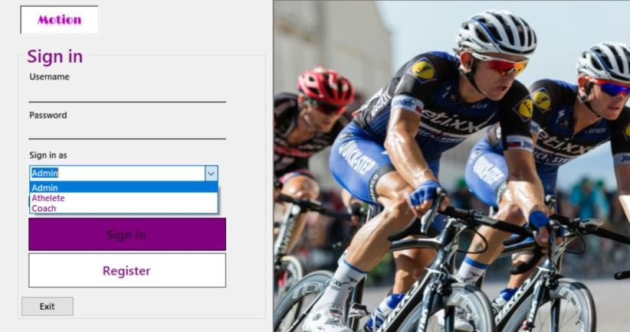

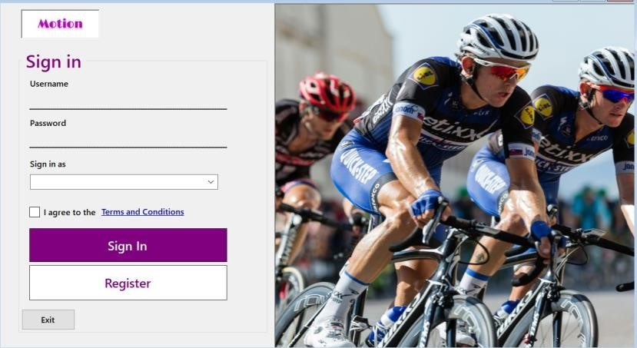

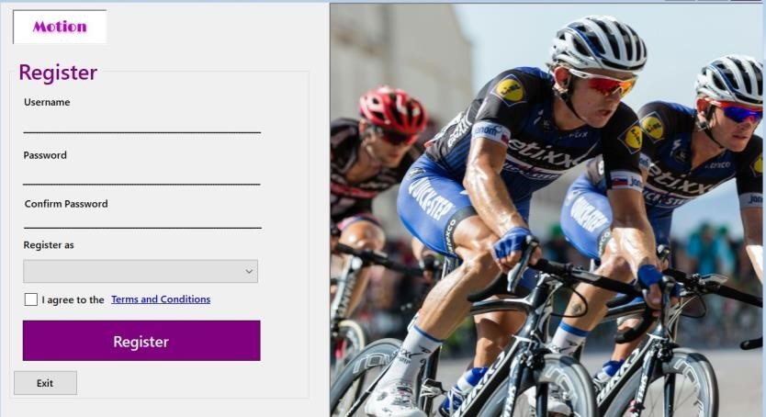
ATHLETE VIEW:
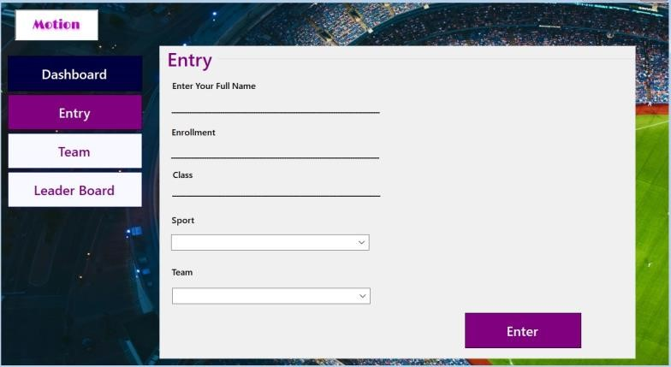

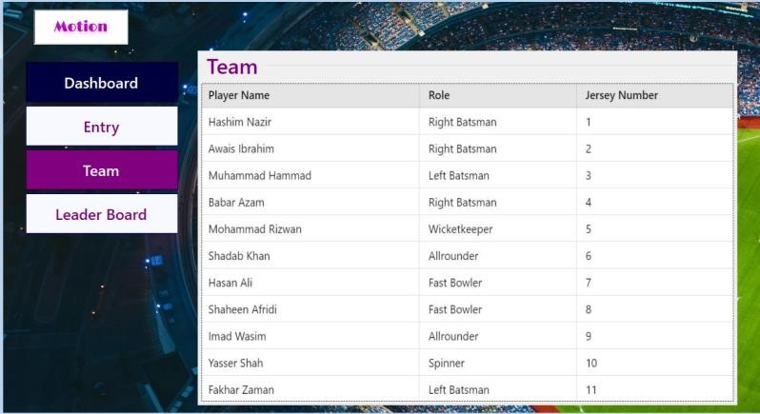

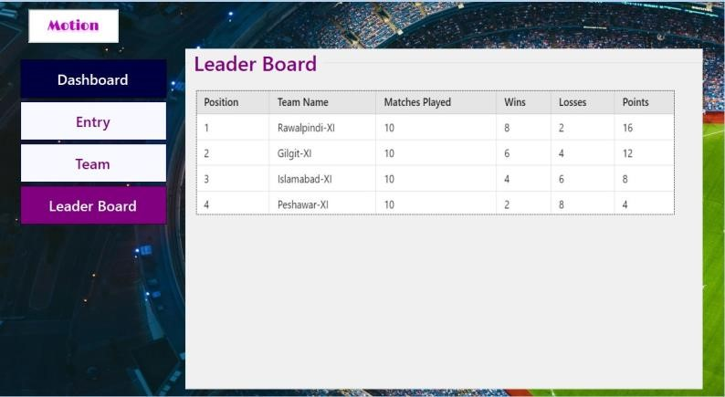

COACH VIEW:
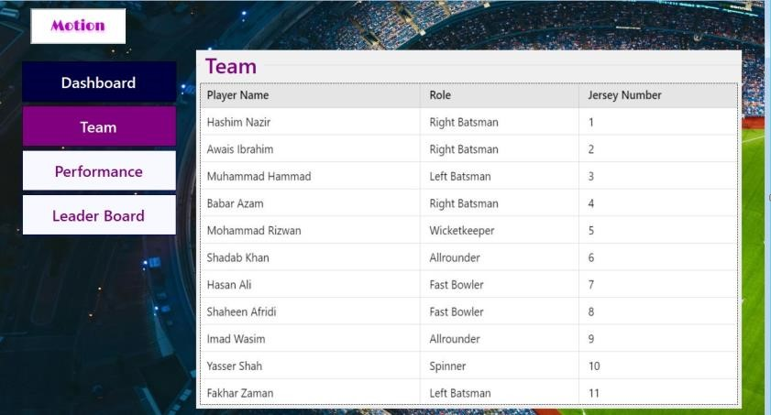

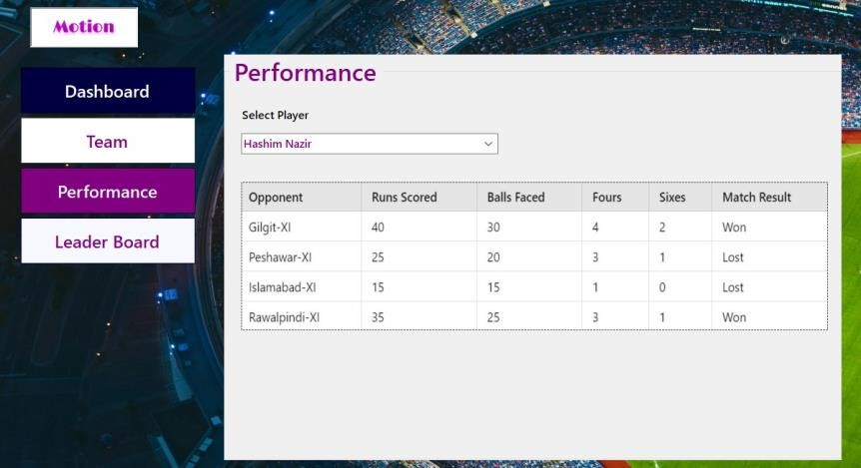

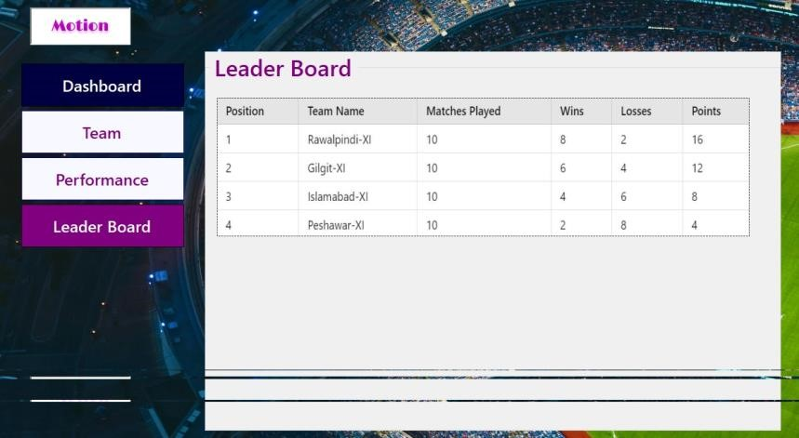

ADMINS VIEW:
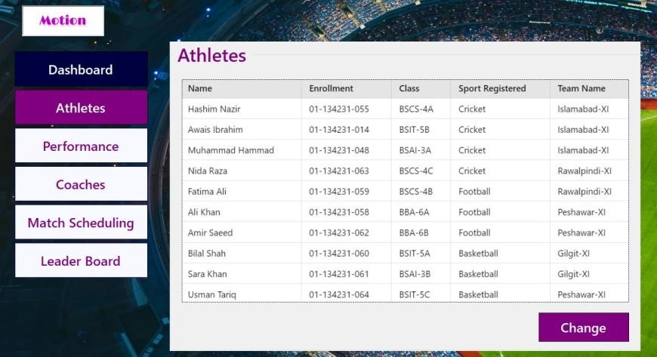

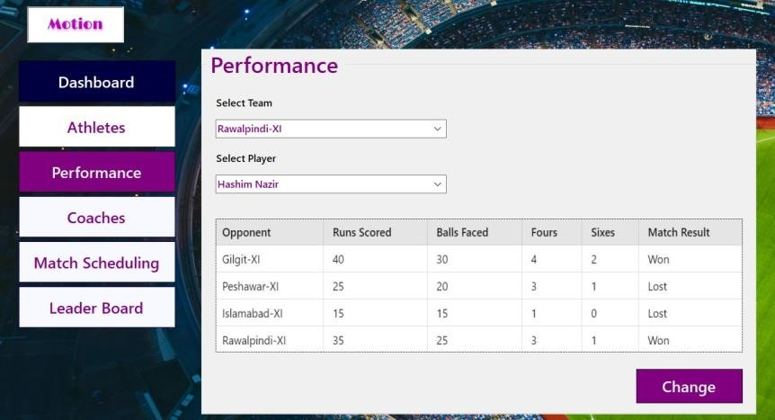

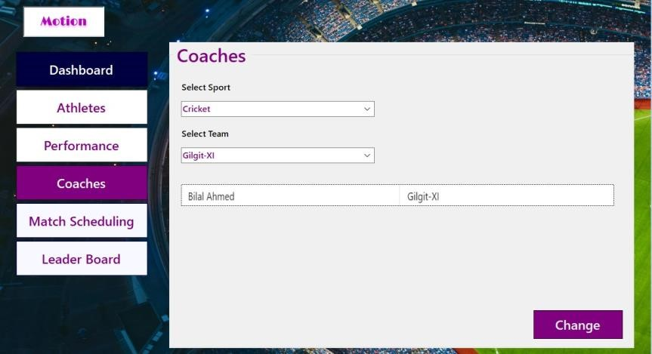

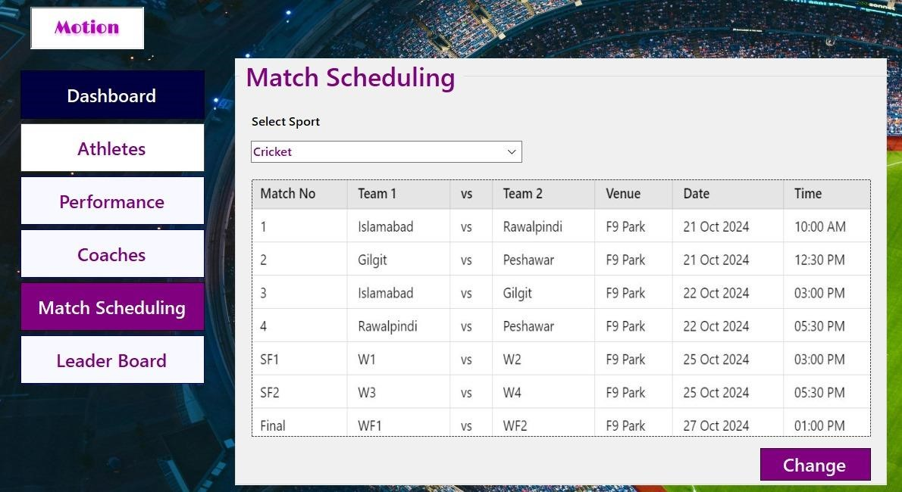

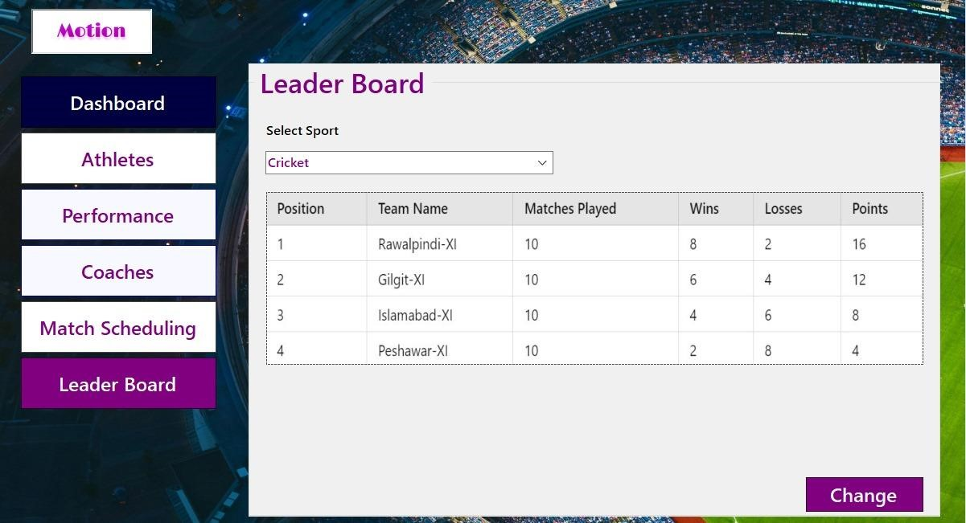

Important Features:

Database Features:
Initial Database Size:
Estimate based on the number of athletes, events, and related data. It majorly depends on the scope of sports event organized with factors like number of teams, number of team members in one team, number of sports being played.
Estimation for a typical sports event management system:
- Athlete and coach profiles: Assuming around 100-500 participants (athletes and coaches), each profile might take up around 2-5 KB.
- Event details: Basic event information (schedule, venue, results) could require around 510 KB per event.
- Logs and transaction records: Depending on the complexity of tracking entry/exits, payments, and performance, logs could consume around 20-100 KB per participant/event.
Rough estimation:
For a normal-sized sports event:
- Textual data (athlete, coach, event info, results): 1-5 MB.
- Logs and performance data: 2-10 MB.
- Multimedia: If media like photos or videos are stored, this could add 1-10 GB or more depending on the quality and duration.
Without multimedia, the system might require around 10-20 MB for basic functionality and data storage. If multimedia storage is involved, the memory size could increase significantly, potentially needing a few GBs of storage.

Database Growth:
Considering athlete additions this could vary vastly, factors like event frequency and performance tracking data size governs the database growth rate. However for a University Sports Management System conducting no more than 5 events per year growth rate should be 100-300 MB / year.

Search Types:
Searches for: athlete : 50+ searches / month ( by admin/ coaches ) event : 5 -10 searches / year performance data : 200- 500 searches /year (by athletes /admin/ coaches)

Networking & Shared Access:
Admins: full access to all the functions of the SMS ( MOTION)
Coach : access to the performance data of the players i.e personal records + leaderboard
Also coach will have the access to manage athletes.
Athlete: Minimum access to functions , personal statistics .
Performance and Security: Security:
Role-based access control (RBAC) to restrict data access. Data encryption for user information. Regular backups and monitoring to prevent data loss or breaches

PART 3
Conceptual Modelling Approach
Approach Used
For this project, we have used the Entity-Relationship Diagram (ERD) approach for conceptual modeling. This approach focuses on identifying the key entities, their attributes, and the relationships between these entities within the domain of the university sports management system. The ERD serves as a visual representation of the database structure, which is essential for understanding the requirements and designing the schema effectively.
The ERD approach involves the following steps:
- Identifying Entities:
We identified key entities such as Athlete, Team, Event, Venue, and Coach.
These entities represent the primary components of the sports management system.
- Defining Attributes:
Each entity was assigned a set of attributes that define its properties, such as enrollment for Athlete, name for Venue, and event_date for Event.
- Establishing Relationships:
The relationships between entities were mapped, such as:
  - An Athlete "is in" a Team.
  - A Team "participates in" an Event.
  - An Event "is held at" a Venue.
  - A Coach "coaches" a Team.

Justification for Using the ERD Approach
- Clarity and Simplicity:
ERDs provide a clear and straightforward way to represent the data and its relationships. This visual representation makes it easier for stakeholders, developers, and database designers to understand the system's structure.
- Systematic Design:
The ERD approach allows for systematic identification of relationships and constraints, ensuring that the system's functional requirements are accurately modeled.
- Logical Data Flow:
By representing how entities interact, the ERD ensures a logical flow of data between entities, making it easier to identify potential redundancies or inconsistencies.
- Flexibility:
ERDs are flexible and scalable, making it easier to adapt to changes in requirements without significantly affecting the conceptual model.
- Standardized Approach:
The ERD approach is a widely accepted standard in database design. Using this approach ensures that the project aligns with industry best practices and is easily interpretable by other database professionals.

Business Rules
Athlete Participation
- An Athlete can participate in at most one team or may not belong to any team.
- A Team must consist of multiple athletes.
Team and Coach Relationship
- Each Team is coached by one and only one coach.
- A Coach can coach one or more teams or may not coach any team.
Team Participation in Events
- A Team can participate in one or many events. • An Event must involve one or more(2) teams.
Event and Venue Relationship
- Each Event must be held at one venue.
- A Venue may host one or more events or may not host any event.
Athlete and Performance Relationship
- An Athlete’s performance is recorded for specific events.
- Each Performance includes roles and have a numeric value and type.
Team and Performance Relationship
- A Team’s Performance is attributed to events it participates in.
- Performances contribute to the Team’s win/loss stats in results.
Sport and Team Relationship
- A Sport must include one or more teams.
- Each Team belongs to one sport.
Coach and Sport Relationship
- A Coach can guide one or more sports.
- A Sport must have at least one coach organizing activities.
Result and Team Relationship
- A Result is awarded to one or more teams based on their performance.
- Results determine whether a Team wins or loses.

Entities and Attributes
Athlete
- Primary Key: Enrollment
- Attributes: o First Name o Last Name o Date of Birth (DOB) o Personal Best o Phone Number o Password o Team ID

Venue
- Primary Key: Name
- Attributes: o Location o Capacity

Event
- Primary Key: Event ID
- Attributes:
o Name o Date o Start Time o End Time o Time Slot

Team
- Primary Key: Name
- Attributes:
  - Name o Wins
  - Loss
  - Statistics

Coach
- Primary Key: Coach ID
- Attributes:
  - Name o Email o Phone
Sport
- Primary Key: Name
- Attributes:
  - Number of Teams
Performance
- Primary Key: (Composite Key: Athlete + Event)
- Attributes: o Numeric Value o Roles o Type

Result
- Primary Key: (Composite Key: Team + Event)
- Attributes: o Win
  - Lose

Relationships
Athlete and Team
- Relationship: "Is In"
- An Athlete belongs to a Team.
- A Team includes multiple Athletes.
Team and Event
- Relationship: "Participates In" • A Team participates in one or more Events.
- An Event includes one or more Teams.
Event and Venue
- Relationship: "Is Held At"
- An Event is held at a Venue.
- A Venue may host multiple Events.
Coach and Team
- Relationship: "Coaches"
- A Coach coaches one and only one Team.
- A Team is coached by one Coach.
Team and Sport
- Relationship: "Belongs To"
- A Team belongs to one Sport.
- A Sport includes one or more Teams.
Coach and Sport
- Relationship: "Guides"
- A Coach guides one or more Sports.
Athlete and Performance
- Relationship: "Recorded For"
- An Athlete’s Performance is recorded for specific Events.
Performance and Event
- Relationship: "Includes"
- A Performance belongs to an Event.
Result and Team
- Relationship: "Awarded To"
- Results are awarded to Teams based on their performances.

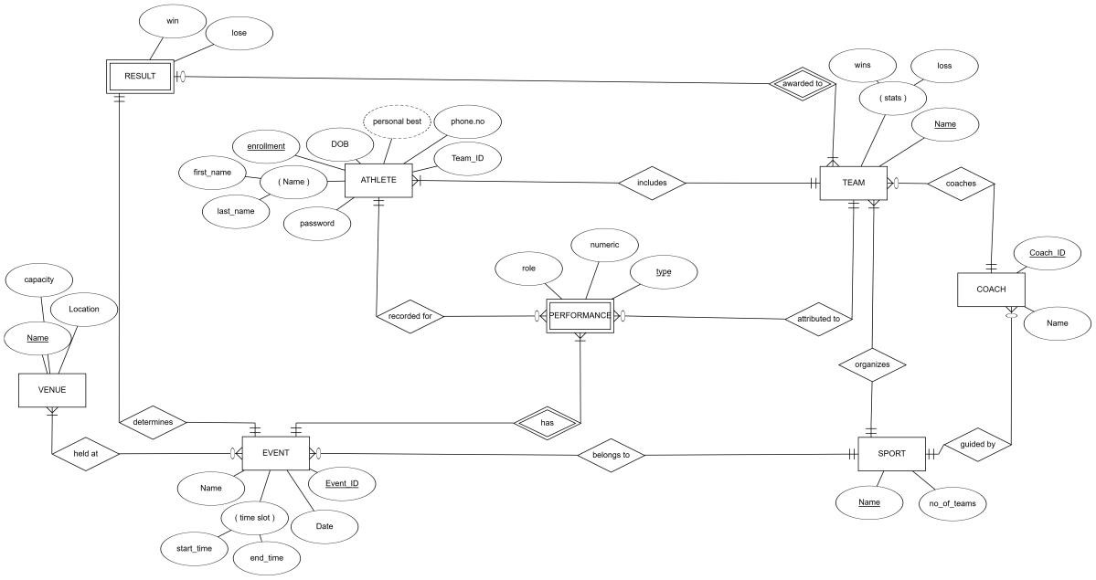
ER DIAGRAM

Relational Schema
Athlete
Attributes:
- enrollment (INT, PRIMARY KEY)
- first_name (VARCHAR)
- last_name (VARCHAR)
- DOB (DATE)
- phone_no (VARCHAR)
- password (VARCHAR)
- personal_best (VARCHAR)
- team_id (FK → Team.team_id)
Team
Attributes:
- team_id (INT, PRIMARY KEY)
- name (VARCHAR)
- wins (INT)
- loss (INT)
- stats (VARCHAR)
- coach_id (FK → Coach.coach_id)
Event
Attributes:
- event_id (INT, PRIMARY KEY)
- name (VARCHAR) • date (DATE)
- start_time (TIME)
- end_time (TIME)
- venue_name (FK → Venue.name)
Venue
Attributes:
- name (VARCHAR, PRIMARY KEY)
- location (VARCHAR)
- capacity (INT)
Coach
Attributes:
- coach_id (INT, PRIMARY KEY)
- name (VARCHAR)
- email (VARCHAR)
- phone (VARCHAR)
Sport
Attributes:
- name (VARCHAR, PRIMARY KEY)
- no_of_teams (INT)
Performance
Attributes:
- athlete_id (FK → Athlete.enrollment)
- event_id (FK → Event.event_id)
- numeric (DECIMAL)
- roles (VARCHAR)
- type (VARCHAR)
- PRIMARY KEY (athlete_id, event_id)
Result
Attributes:
- team_id (FK → Team.team_id)
- event_id (FK → Event.event_id)
- win (BOOLEAN)
- lose (BOOLEAN)
- PRIMARY KEY (team_id, event_id)
•

Constraints

Entity Integrity Constraints
Each table's Primary Key must be unique and non-null.
- enrollment for Athlete.
- team_id for Team.
- event_id for Event.
- name for Venue and Sport.
- coach_id for Coach.
Referential Integrity Constraints
- team_id in Athlete → team_id in Team.
- coach_id in Team → coach_id in Coach.
- venue_name in Event → name in Venue.
- athlete_id in Performance → enrollment in Athlete.
- event_id in Performance → event_id in Event.
- team_id in Result → team_id in Team.
- event_id in Result → event_id in Event.

Domain Definitions
Athlete
- first_name, last_name, personal_best: VARCHAR (50).
- enrollment: INT (6-10 digits).
- DOB: DATE.
- phone_no: VARCHAR (15). • password: VARCHAR (50).
Team
- team_id: INT.
- name: VARCHAR (50).
- wins, loss: INT.
- stats: VARCHAR (255).
Event
- event_id: INT.
- name: VARCHAR (50).
- date: DATE.
- start_time, end_time: TIME.
- venue_name: VARCHAR (50).
Venue
- name: VARCHAR (50).
- location: VARCHAR (100).
- capacity: INT.
Coach
- coach_id: INT (6-10 digits).
- name, email: VARCHAR (50).
- phone: VARCHAR (15).
Sport
- name: VARCHAR (50).
- no_of_teams: INT.
Performance
- numeric: DECIMAL (5,2).
- roles: VARCHAR (50).
- type: VARCHAR (50).
Result
- win, lose: BOOLEAN.

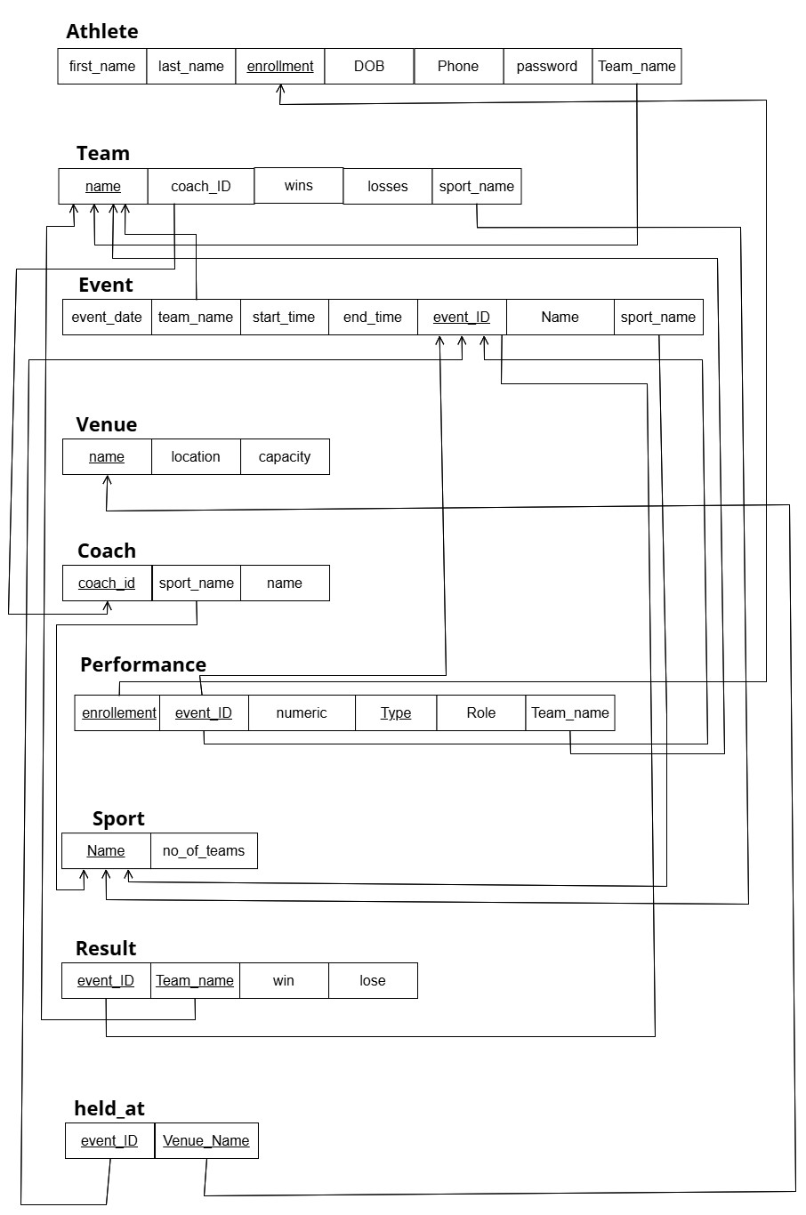
RELATIONAL SCHEMA

1NF (First Normal Form)
Objective:
Eliminate repeating groups and ensure atomicity.
- All columns contain atomic (indivisible) values.
- Each row is uniquely identifiable, typically using a primary key. ➢ Any multi-valued attributes or nested relations are removed.
Result:
The tables were already in the 1st normal form, so no changes made.

2NF (Second Normal Form) Objective:
- Eliminate partial dependency.
- All non-prime attributes (attributes not part of the primary key) must depend on the entire primary key, not just a part of it.
- This step applies only if the table has a composite primary key.
Changes Made:
- Tables with partial dependencies are split into smaller tables.
- Each non-prime attribute is moved to the table where it fully depends on the primary key.
Result:
The tables were already in the 2nd normal form, so no changes made.

3NF (Third Normal Form)
Objective:
- Eliminate transitive dependency.
- Non-prime attributes must depend only on the primary key and not on any other non-prime attribute.
Changes Made:
- Attributes that are transitively dependent are moved into separate tables.
- Each table now represents a single concept or entity.

Result:
In the performance table, few changes are made
- The role (non-primary attribute) was defining another non primary attribute type so column, type would be dropped
- A new table role is created with primary key role_ and it has type attribute
- Now the role attribute in the performance table would become foreign key from the role table.

Final Normalized Tables
After the normalization process, the database schema is organized into a set of tables, each representing a distinct entity or relationship. Relationships between these tables are maintained using foreign keys.

Following the final normalized tables from our dartabase
Athltete
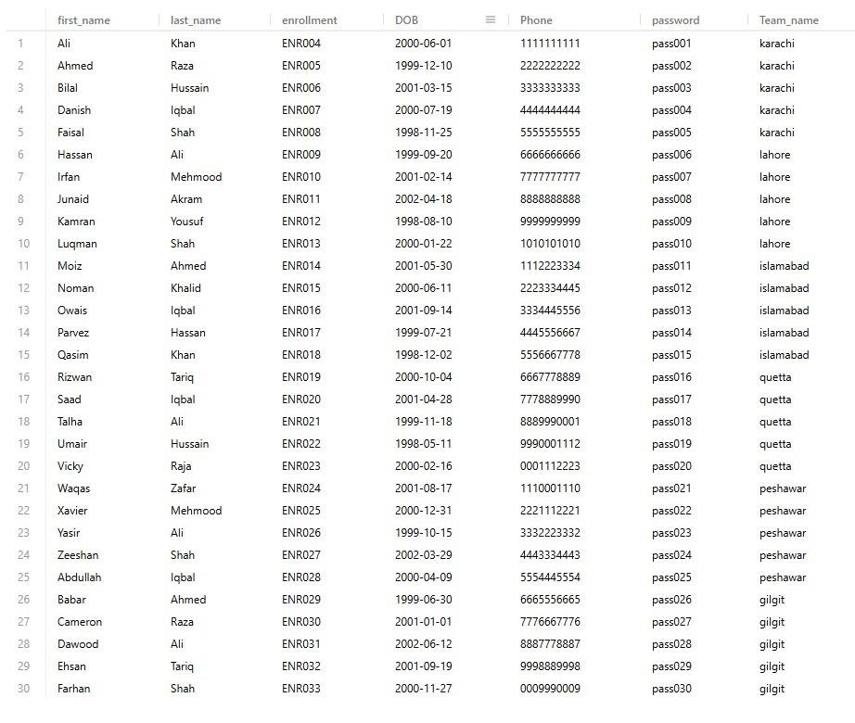
Team
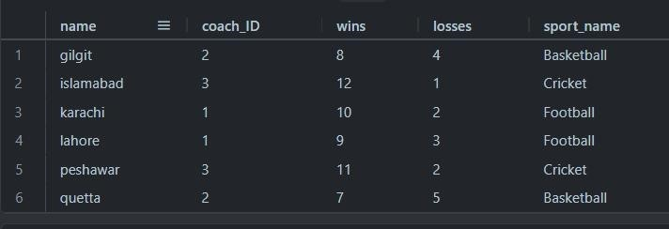
Event
Venue
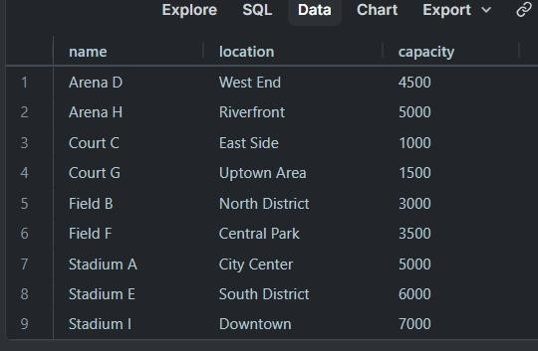
Coach
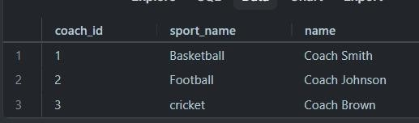
Performance
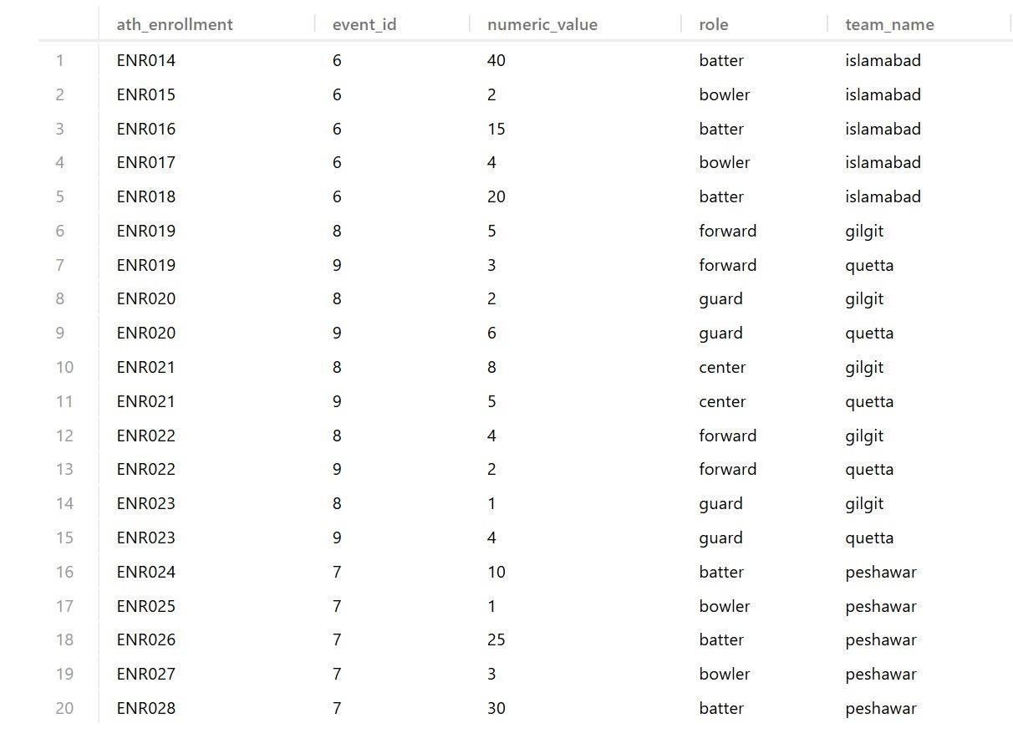
Role
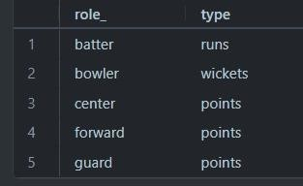
Sport
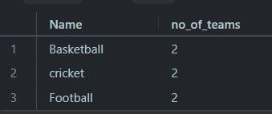
Result
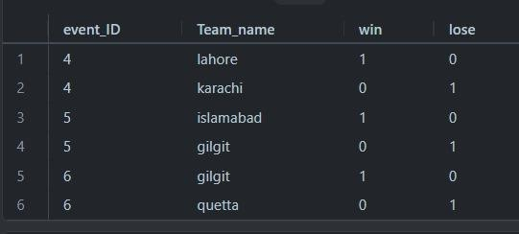
Held_at
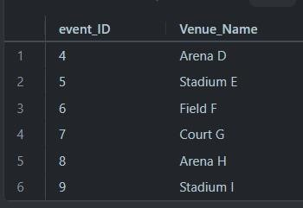
DDL Commands:
1. Create Database

Explanation: Create a new database named SportEventManagement and set it as active for subsequent queries.
Sql:
CREATE DATABASE SportsEventManagement;
USE SportsEventManagement; 2. Create Tables
a. Athlete Table
Explanation: Stores athlete details, including a unique enrollment number and references to their team.
Sql:
CREATE TABLE Athlete ( athlete_ID INT AUTO_INCREMENT PRIMARY KEY, first_name VARCHAR(50) NOT NULL, last_name VARCHAR(50) NOT NULL, enrollment VARCHAR(20) UNIQUE NOT NULL,
DOB DATE NOT NULL, Phone VARCHAR(15), password VARCHAR(50) NOT NULL,
Team_name VARCHAR(50),
FOREIGN KEY (Team_name) REFERENCES Team(name)
);
b. Team Table
Explanation: Holds team details such as their name, associated coach, and performance statistics. It references the Coach and Sport tables.
Sql:
CREATE TABLE Team ( team_ID INT AUTO_INCREMENT PRIMARY KEY, name VARCHAR(50) UNIQUE NOT NULL,
coach_ID INT, wins INT, losses INT,
sport_name VARCHAR(50),
FOREIGN KEY (coach_ID) REFERENCES Coach(coach_id),
FOREIGN KEY (sport_name) REFERENCES Sport(Name)
);
c. Event Table
Explanation: Stores event information, including associated teams, sport type, and timing details
Sql:
CREATE TABLE Event ( event_date DATE, team_name VARCHAR(50), start_time TIME,
end_time TIME, event_ID INT PRIMARY KEY,
Name VARCHAR(50), sport_name VARCHAR(50),
FOREIGN KEY (team_name) REFERENCES Team(name),
FOREIGN KEY (sport_name) REFERENCES Sport(Name)
);
- Venue Table
Explanation: Contains information about venues, including their name, location, and seating capacity.
Sql:
CREATE TABLE Venue ( name VARCHAR(50) PRIMARY KEY, location VARCHAR(100), capacity INT
);
- Coach Table
Explanation: Stores details about coaches, including their name and associated sport.
Sql:
CREATE TABLE Coach (
coach_id INT PRIMARY KEY, sport_name VARCHAR(50), name VARCHAR(50),
FOREIGN KEY (sport_name) REFERENCES Sport(Name)
);
- Sport Table
Explanation: Holds metadata about different sports, including the number of teams participating.
Sql:
CREATE TABLE Sport (
Name VARCHAR(255) PRIMARY KEY, no_of_teams INT
);
- Performance Table
Explanation: Tracks athlete performance metrics in events. References Athlete, Event, and Team tables.
Sql:
CREATE TABLE Performance ( ath_enrollment VARCHAR(50) NOT NULL, event_id INT NOT NULL, numeric_value INT NOT NULL,
type VARCHAR(50) NOT NULL, role VARCHAR(50), team_name VARCHAR(100),
PRIMARY KEY (ath_enrollment, event_id, type),
FOREIGN KEY (ath_enrollment) REFERENCES Athlete(enrollment) ON
DELETE CASCADE,
FOREIGN KEY (event_id) REFERENCES Event(event_ID) ON DELETE
CASCADE,
FOREIGN KEY (team_name) REFERENCES Team(name) ON DELETE
SET NULL
);
h. Result Table
Explanation: Contains the outcome of events for each team, including win/loss records.
Sql:
CREATE TABLE Result ( event_ID INT,
Team_name VARCHAR(255),
win INT, lose INT,
FOREIGN KEY (event_ID) REFERENCES Event(event_ID) ON DELETE
CASCADE,
FOREIGN KEY (Team_name) REFERENCES Team(name) ON DELETE
CASCADE
);
i. Held_at Table
Explanation: Links events to venues, referencing the Event and Venue tables.
CREATE TABLE Held_at ( event_ID INT,
Venue_Name VARCHAR(255),
FOREIGN KEY (event_ID) REFERENCES Event(event_ID),
FOREIGN KEY (Venue_Name) REFERENCES Venue(name)
);
3. Insert Sample Data
- Insert Teams
Explanation: Adds sample team data with their associated sport and performance stats.
Sql:
INSERT INTO Team (name, coach_ID, wins, losses, sport_name)
VALUES
('karachi', 1, 10, 2, 'Football'),
('gilgit', 2, 8, 4, 'Basketball'),
('islamabad', 3, 12, 1, 'Cricket');
- Insert Athletes
Explanation: Adds sample athlete data with their enrollment, team association, and personal details
Sql:
INSERT INTO Athlete (first_name, last_name, enrollment, DOB, Phone, password, Team_name)
VALUES
('awais', 'abrahim', 'ENR001', '2000-05-15', '1234567890', 'pass123', 'karachi'),
('hashim', 'nair', 'ENR002', '2001-08-22', '9876543210', 'pass456', 'gilgit'),
('muhammad', 'hammad', 'ENR003', '1999-11-12', '5678901234', 'pass789',
'islamabad');
c. Insert Events
Explanation: Adds events with their associated teams, schedule, and sport.
Sql:
INSERT INTO Event (event_date, team_name, start_time, end_time, event_ID, Name, sport_name)
VALUES
('2024-06-01', 'islamabad', '10:00:00', '12:00:00', 1, 'Event One',
'Basketball'),
('2024-06-02', 'karachi', '13:00:00', '15:00:00', 2, 'Event Two', 'Football'), ('2024-06-03', 'gilgit', '15:30:00', '17:30:00', 3, 'Event Three', 'Tennis');
d.Insert Coach:
INSERT INTO Coach (coach_id, sport_name, name)
VALUES
(4, 'Cricket', 'Coach Williams'),
(5, 'Basketball', 'Coach Davis'), (6, 'Football', 'Coach Taylor');
e. Insert Event:
INSERT INTO Event (event_date, team_name, start_time, end_time, event_ID, Name, sport_name)
VALUES
('2024-06-04', 'gilgit', '09:00:00', '11:00:00', 4, 'Event Four', 'Cricket'),
('2024-06-05', 'karachi', '12:30:00', '14:30:00', 5, 'Event Five', 'Basketball'), ('2024-06-06', 'islamabad', '15:00:00', '17:00:00', 6, 'Event Six', 'Football');
f.Insert Venue
INSERT INTO Venue (name, location, capacity)
VALUES
('Arena D', 'South End', 7000),
('Ground E', 'West Valley', 2500), ('Hall F', 'Central Square', 1500);
g.Insert Held_at:
INSERT INTO Held_at (event_ID, Venue_Name)
VALUES
(4, 'Arena D'),
(5, 'Ground E'),
(6, 'Hall F');
h.Insert Performance:
INSERT INTO Performance (ath_enrollment, event_id, numeric_value, type, role, team_name)
VALUES
('ENR004', 4, 60, 'runs', 'batter', 'karachi'),
('ENR005', 5, 4, 'assists', 'forward', 'islamabad'), ('ENR006', 6, 2, 'goals', 'goalkeeper', 'karachi');
i.Insert result:
INSERT INTO Result (event_ID, Team_name, win, lose)
VALUES
(4, 'karachi', 10, 4),
(5, 'gilgit', 7, 6),
(6, 'islamabad', 5, 7);

